Report on Network Topology Implementation Using Cisco Packet Tracer

Objective

The purpose of this report is to document the process of implementing various network topologies using Cisco Packet Tracer and to test the connectivity among devices within each topology.

Tool Used

-Cisco Packet Tracer: A powerful network simulation tool that allows users to design, configure, and troubleshoot virtual networks.

Implemented Topologies

1. Bus Topology

- **Components Used**: Three computers and a coaxial cable.

- **Implementation Steps**:

1. Dragged three computers onto the workspace.

2. Connected the computers using a single backbone (coaxial) cable.

#### Diagram:

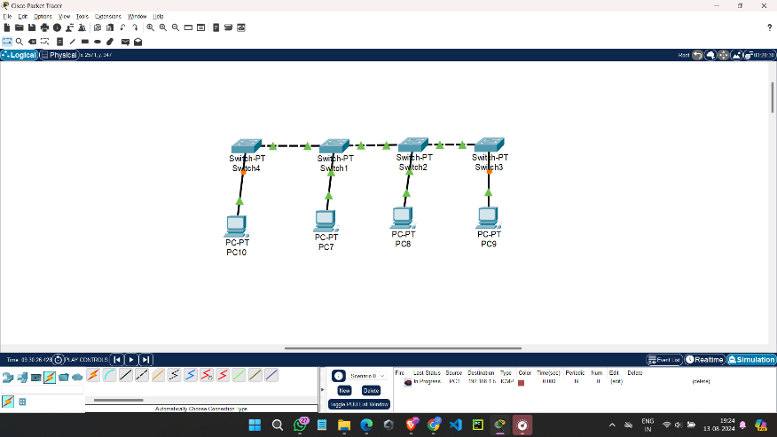

[PC1]-----[PC2]-----[PC3]

2. Star Topology

- **Components Used**: Three computers and a switch.

- **Implementation Steps**:

1. Dragged three computers and a switch onto the workspace.

2. Connected each computer to the switch using straight-through Ethernet cables.

Diagram:

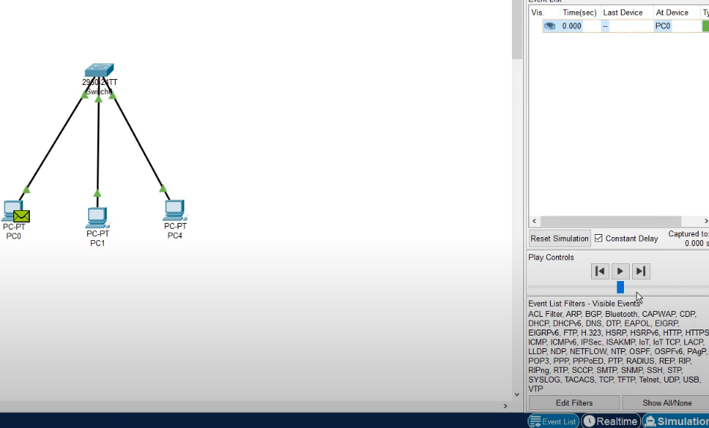

[Switch]

/ | \

[PC1] [PC2] [PC3]

3. Ring Topology

- **Components Used**: Three computers.

- **Implementation Steps**:

1. Dragged three computers onto the workspace.

2. Connected them in a circular manner using crossover cables.

### Diagram:

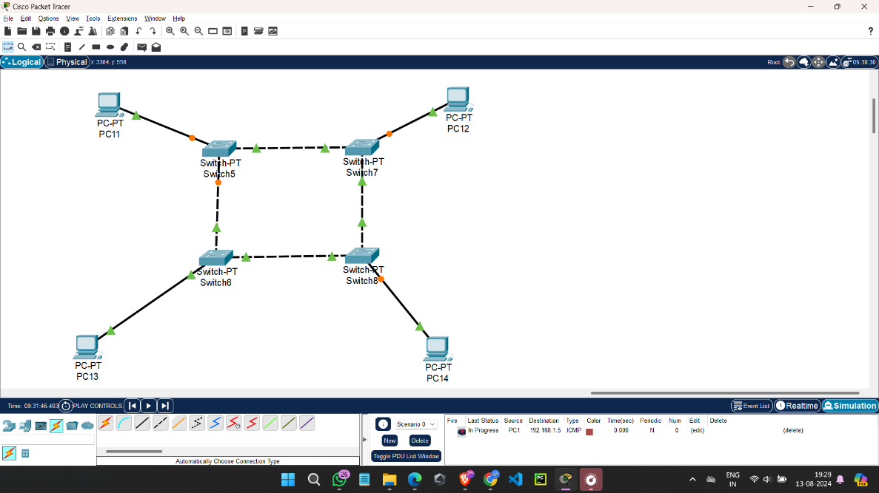

4. Mesh Topology

- **Components Used**:

Three computers.

- **Implementation Steps**:

1. Dragged three computers onto the workspace.

2. Connected each computer to every other computer using crossover cables.

#### Diagram:

[PC1]

/ \

[PC2]--[PC3]

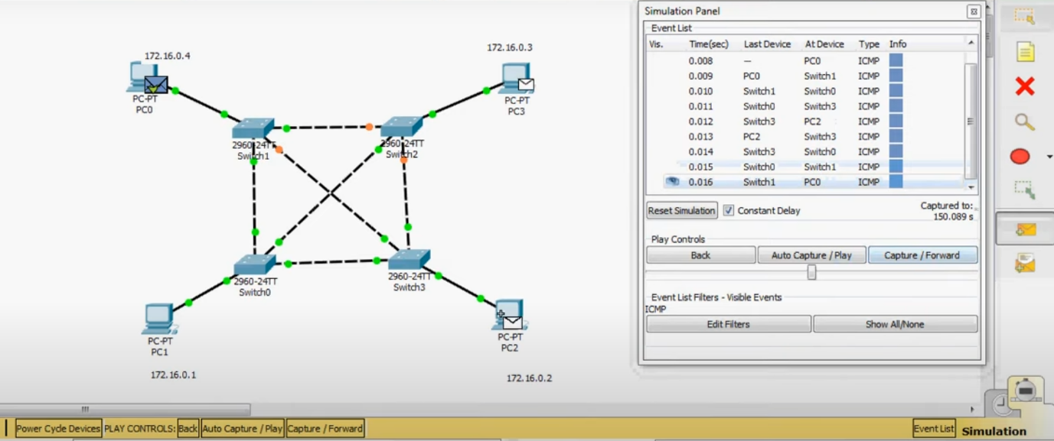

Testing Connectivity

For each topology, IP addresses were assigned to the computers. The IP addresses used for testing are as follows:

- **Bus Topology**:

- PC1: 192.168.1.1

- PC2: 192.168.1.2

- PC3: 192.168.1.3

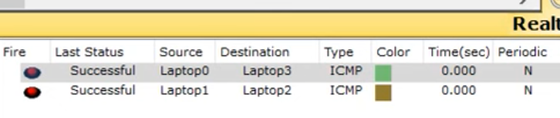

**Star Topology**:

- PC1: 192.168.2.1

- PC2: 192.168.2.2

- PC3: 192.168.2.3

**Ring Topology**:

- PC1: 192.168.3.1

- PC2: 192.168.3.2

- PC3: 192.168.3.3

**Mesh Topology**:

- PC1: 192.168.4.1

- PC2: 192.168.4.2

- PC3: 192.168.4.3

### Connectivity Test

The `ping` command was used to test connectivity between all computers in each topology:

- **Results**:

- **Bus Topology**: All computers successfully pinged each other.

- **Star Topology**: All computers successfully pinged each other through the switch.

- **Ring Topology**: All computers successfully pinged each other in the circular configuration.

- **Mesh Topology**: All computers successfully pinged each other, demonstrating complete connectivity.

---

## Conclusion

The implementation of various network topologies using Cisco Packet Tracer was successful. Each topology was established correctly, and connectivity tests confirmed that all computers were able to communicate effectively according to the characteristics of the respective topology. These results highlight the functionality and reliability of network configurations in a simulated environment. Further exploration and testing could include additional devices and more complex configurations to enhance understanding of network design principles.